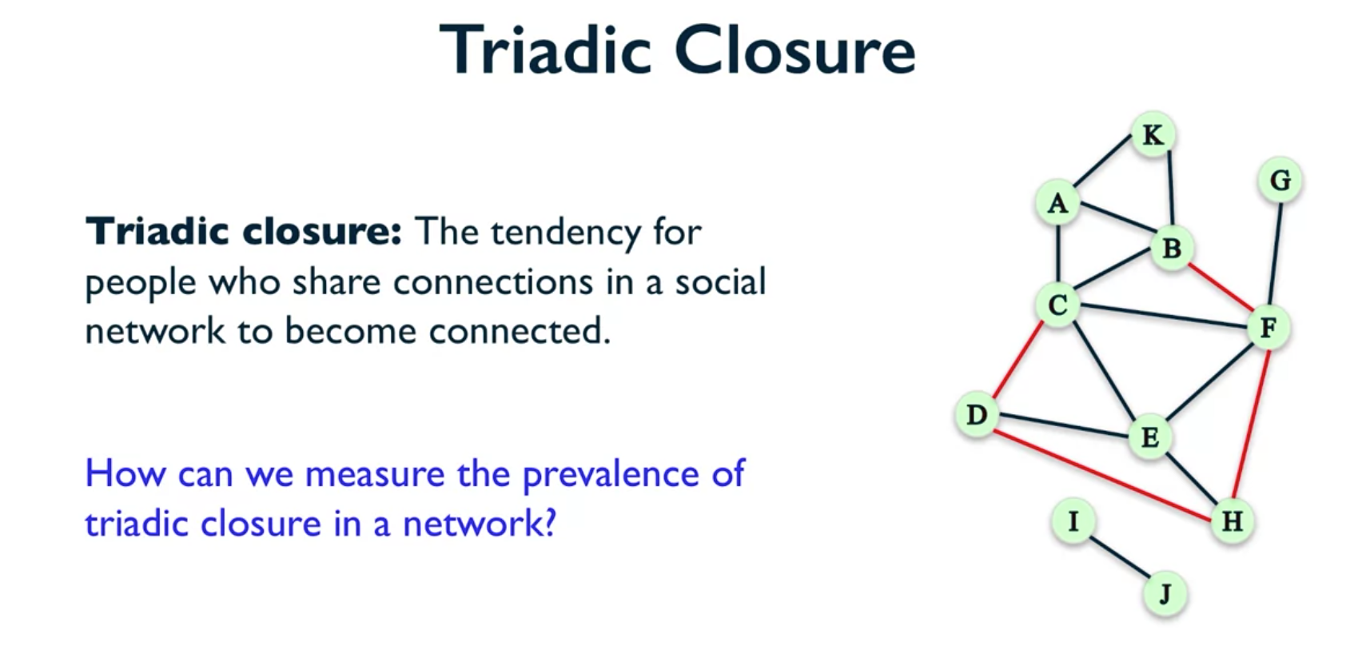

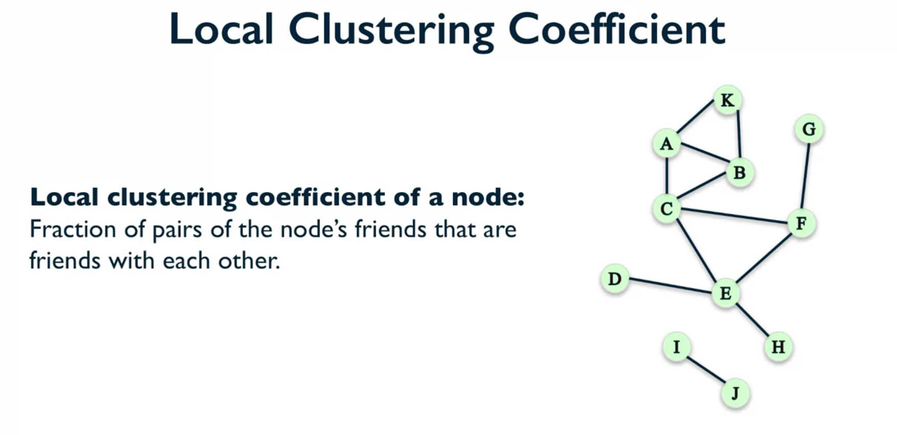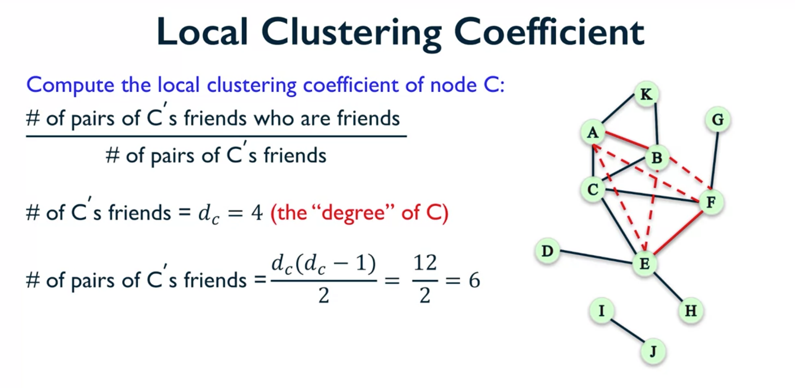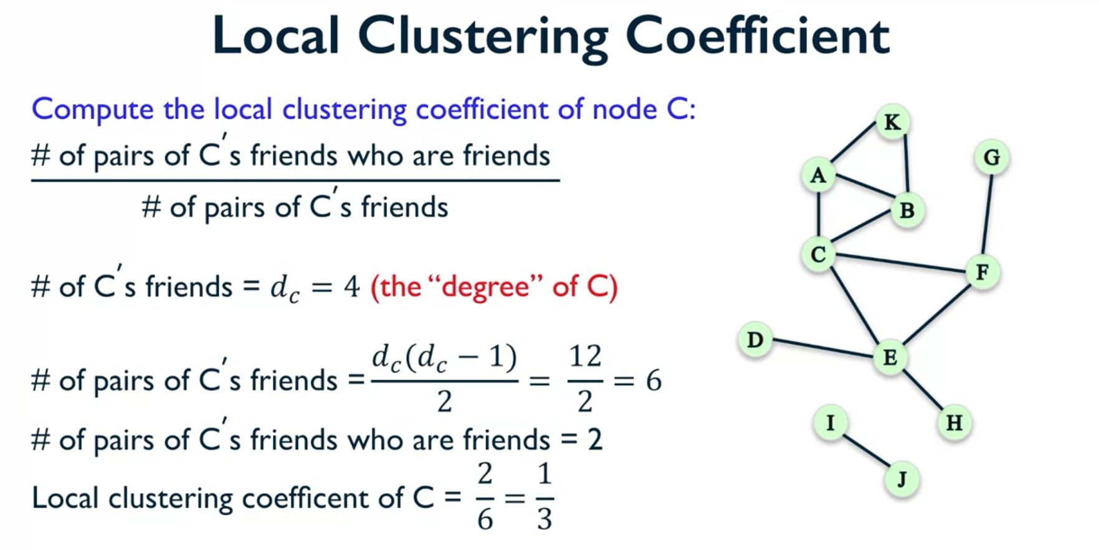

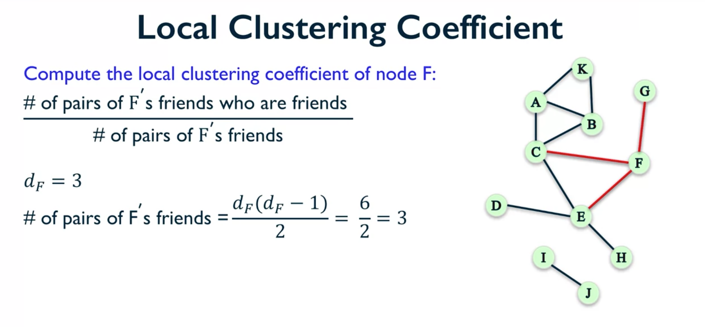

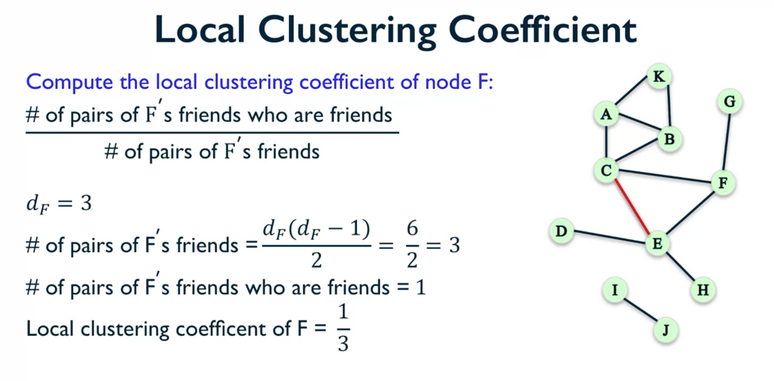

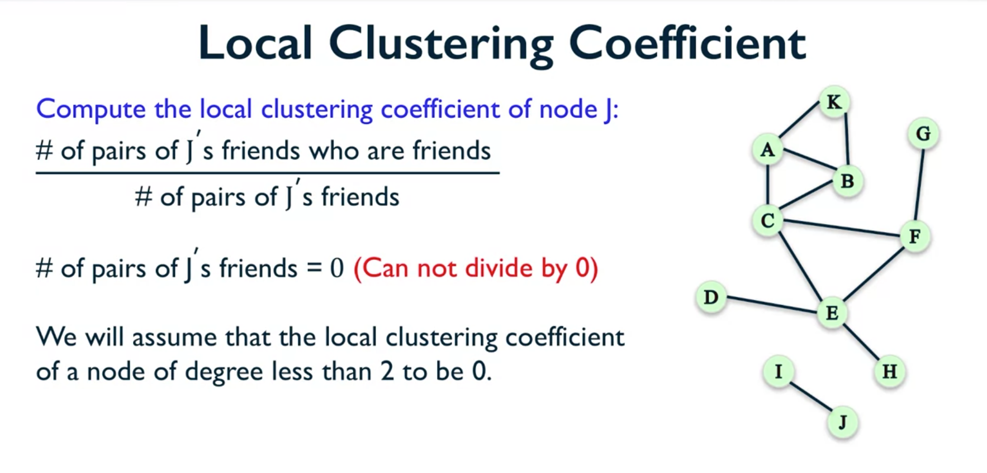

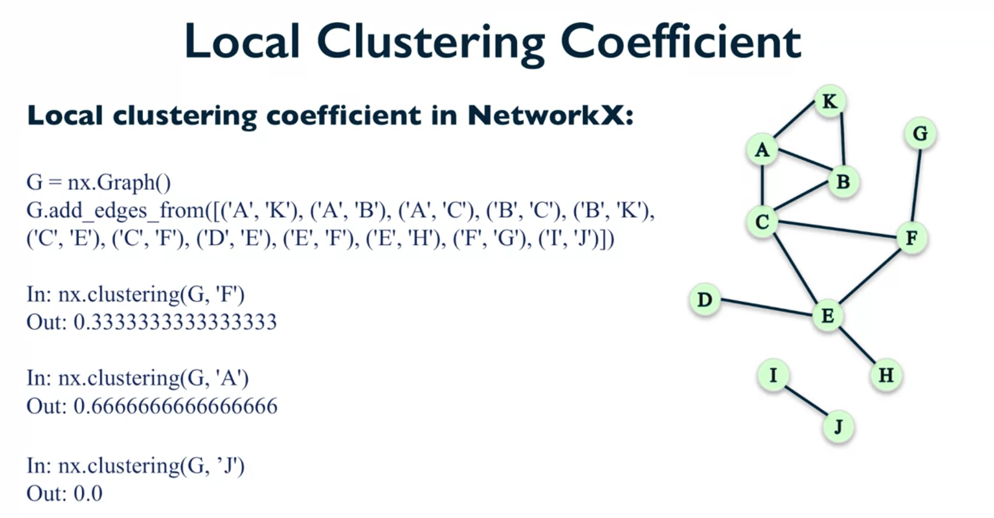

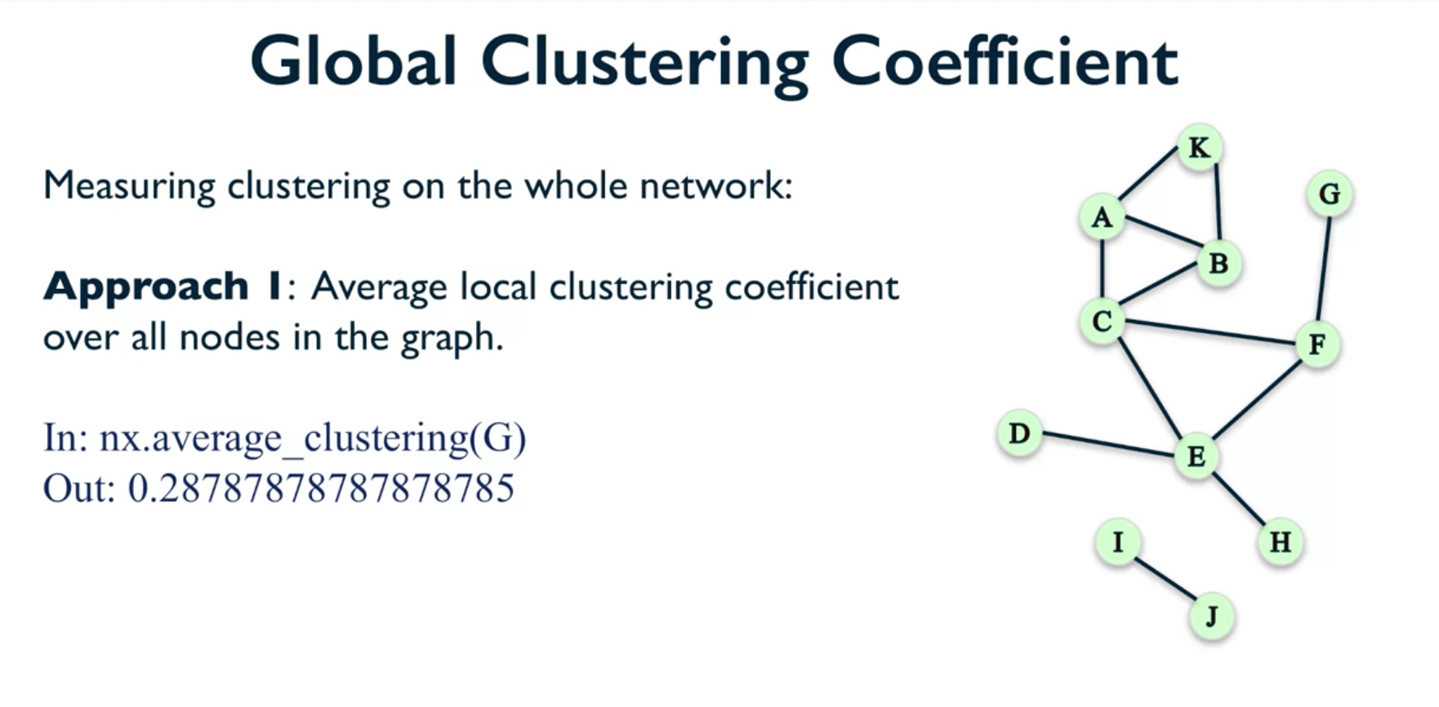

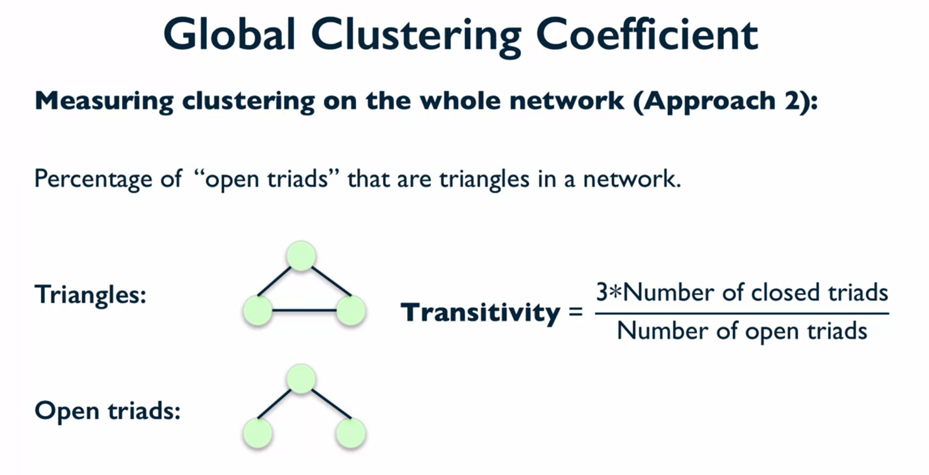

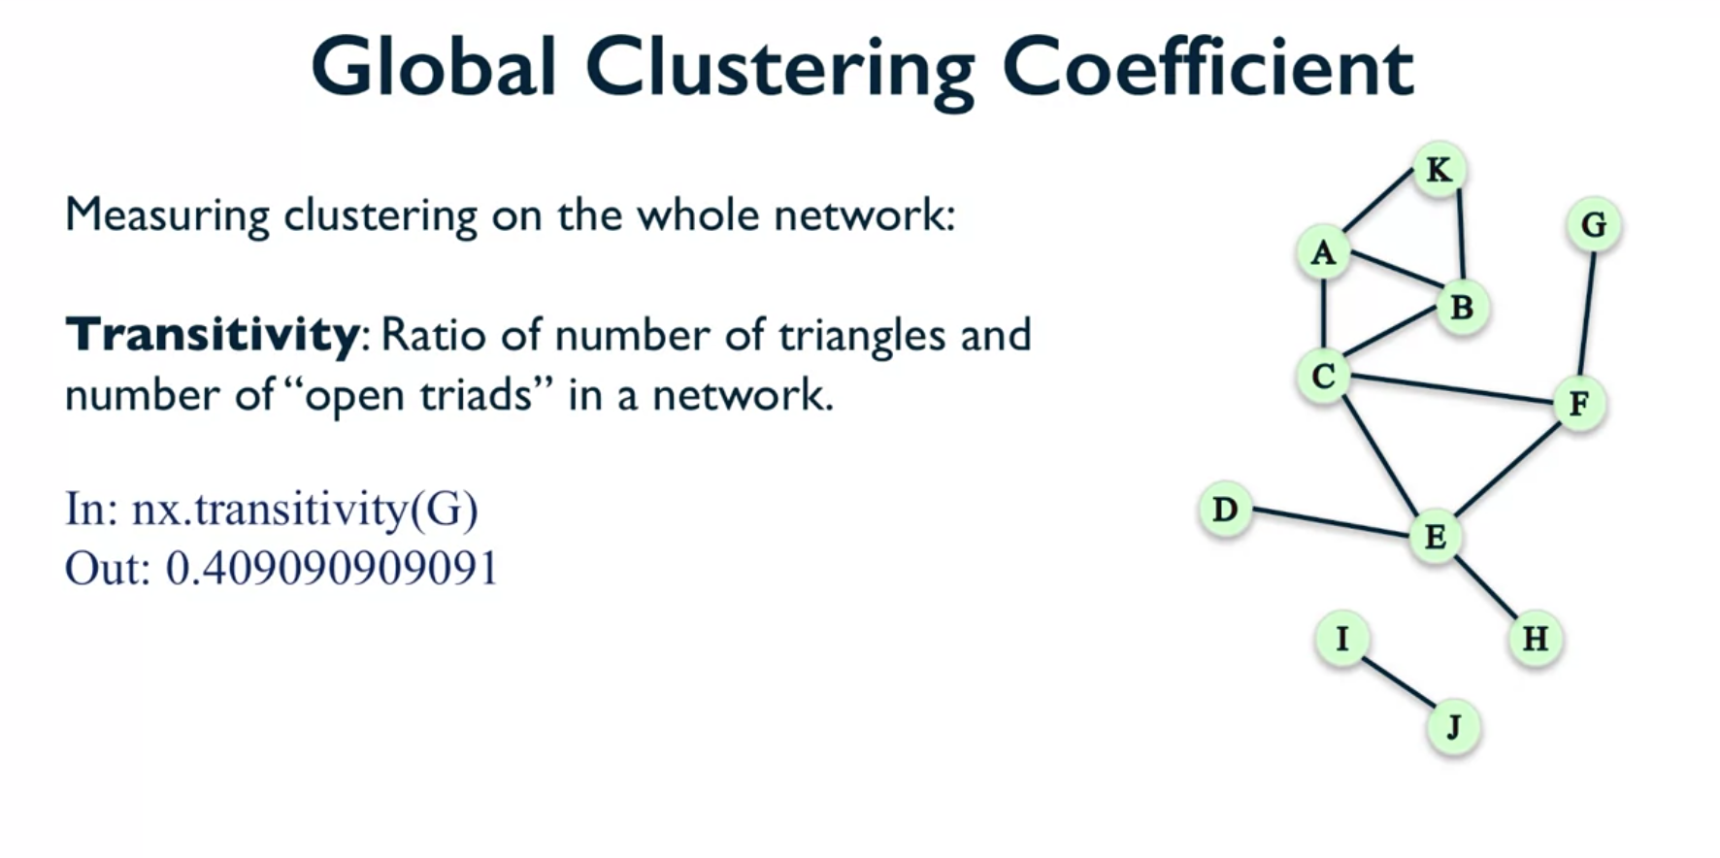

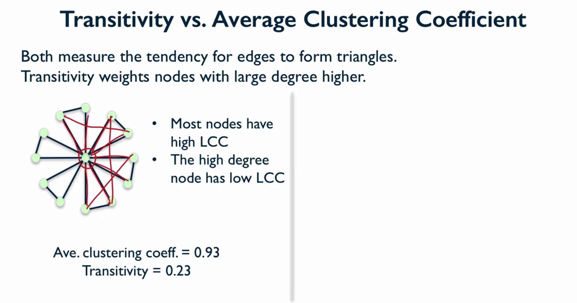

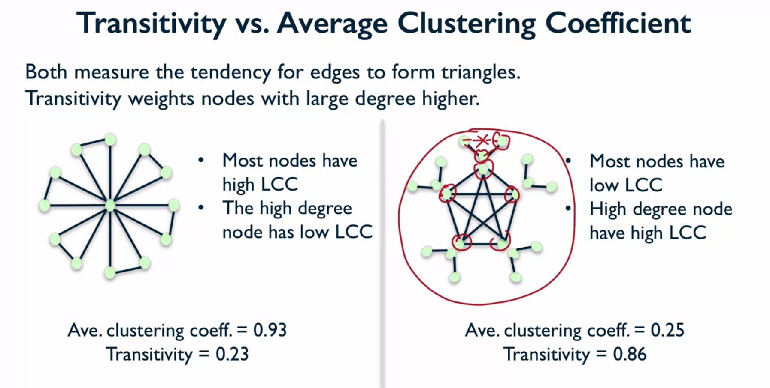

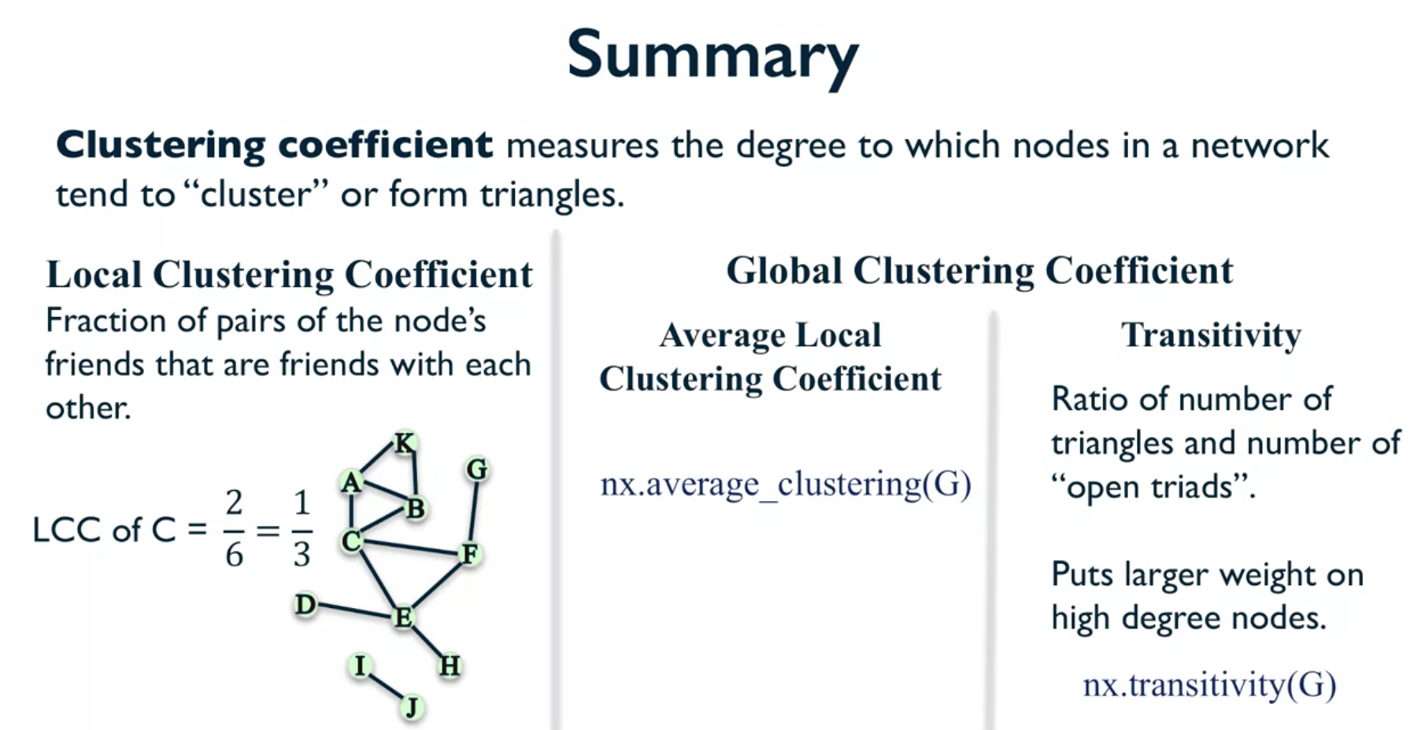

In summary, we've learned that Clustering Coefficient measures the degree to which nodes in a network tend to cluster or form triangles. And there are several ways in which you can measure this. So, the first way, we look at the Local Clustering Coefficient and this is measured on a node by node basis. And in two other ways, we found the global Clustering Coefficient which measures Clustering Coefficient on a global scale for the whole network. For the Local Clustering Coefficient, this one is defined as simply the fraction of pairs of nodes friends who are friends with each other. And just to remind you, in this case, the Local Clustering Coefficient of node C was one-third because one-third of the pairs of friends of C are actually friends with each other. For global Clustering Coefficient, the first way in which we could measure these was by simply taking the average of the Local Clustering Coefficient over all the nodes. And you could use the function average Clustering in network X to do it. And then, the second way was this thing called Transitivity, which was the ratio of the number of triangles and the number of open triads in a network. And this one puts a larger weight on high degree nodes compared to the average Local Clustering Coefficient and you can measure it in network X using the function Transitivity. This is all for today. Thank you for watching. And I hope to see you next time.

*Distance Measures*

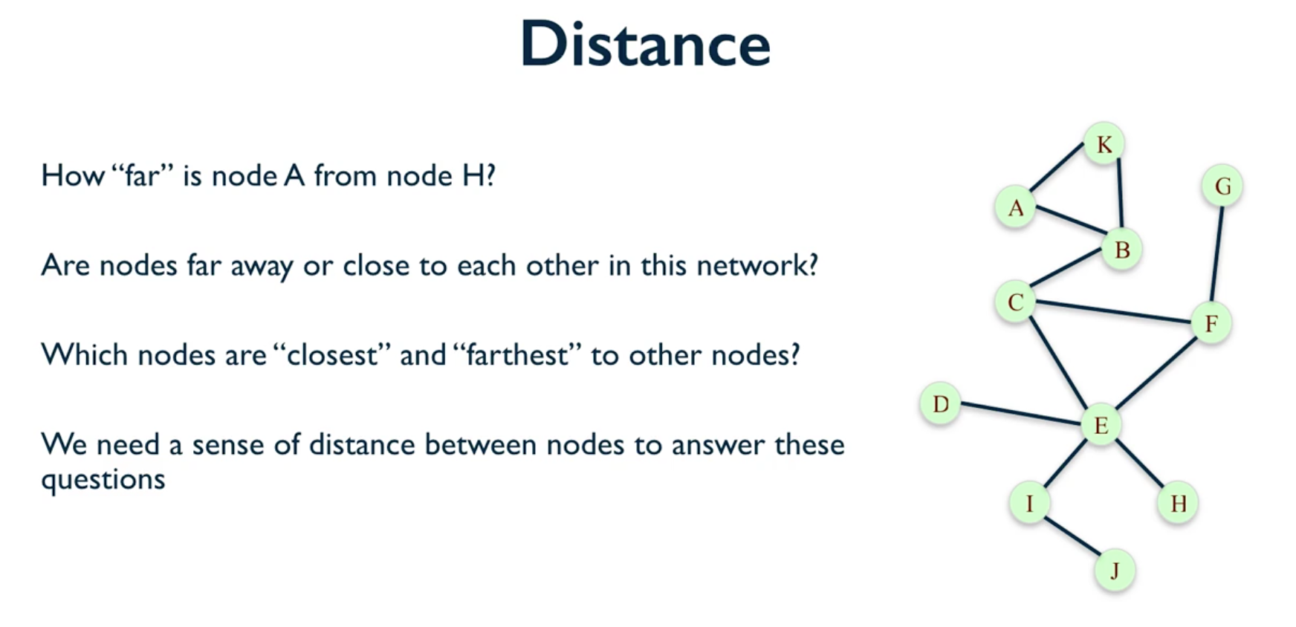

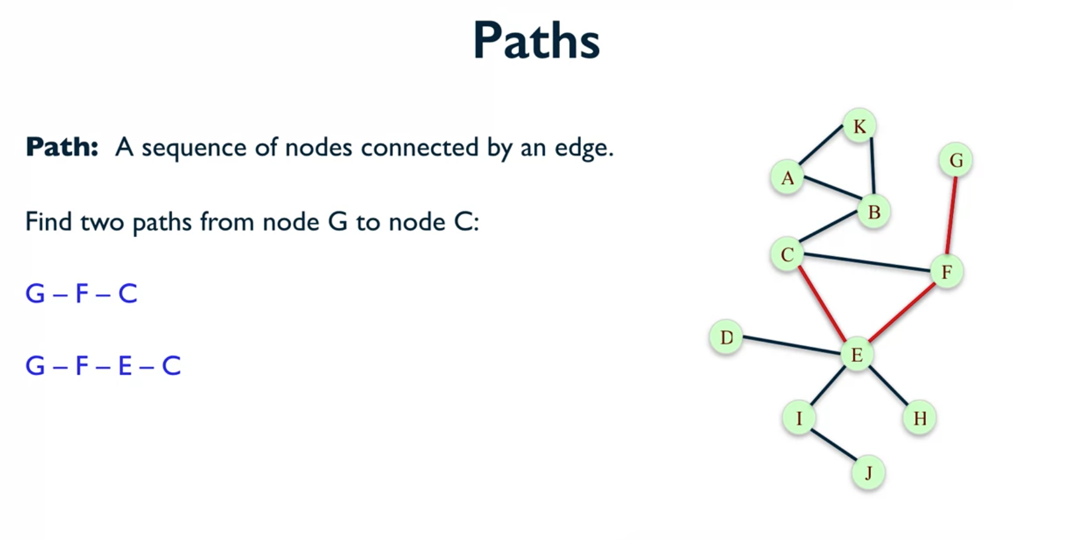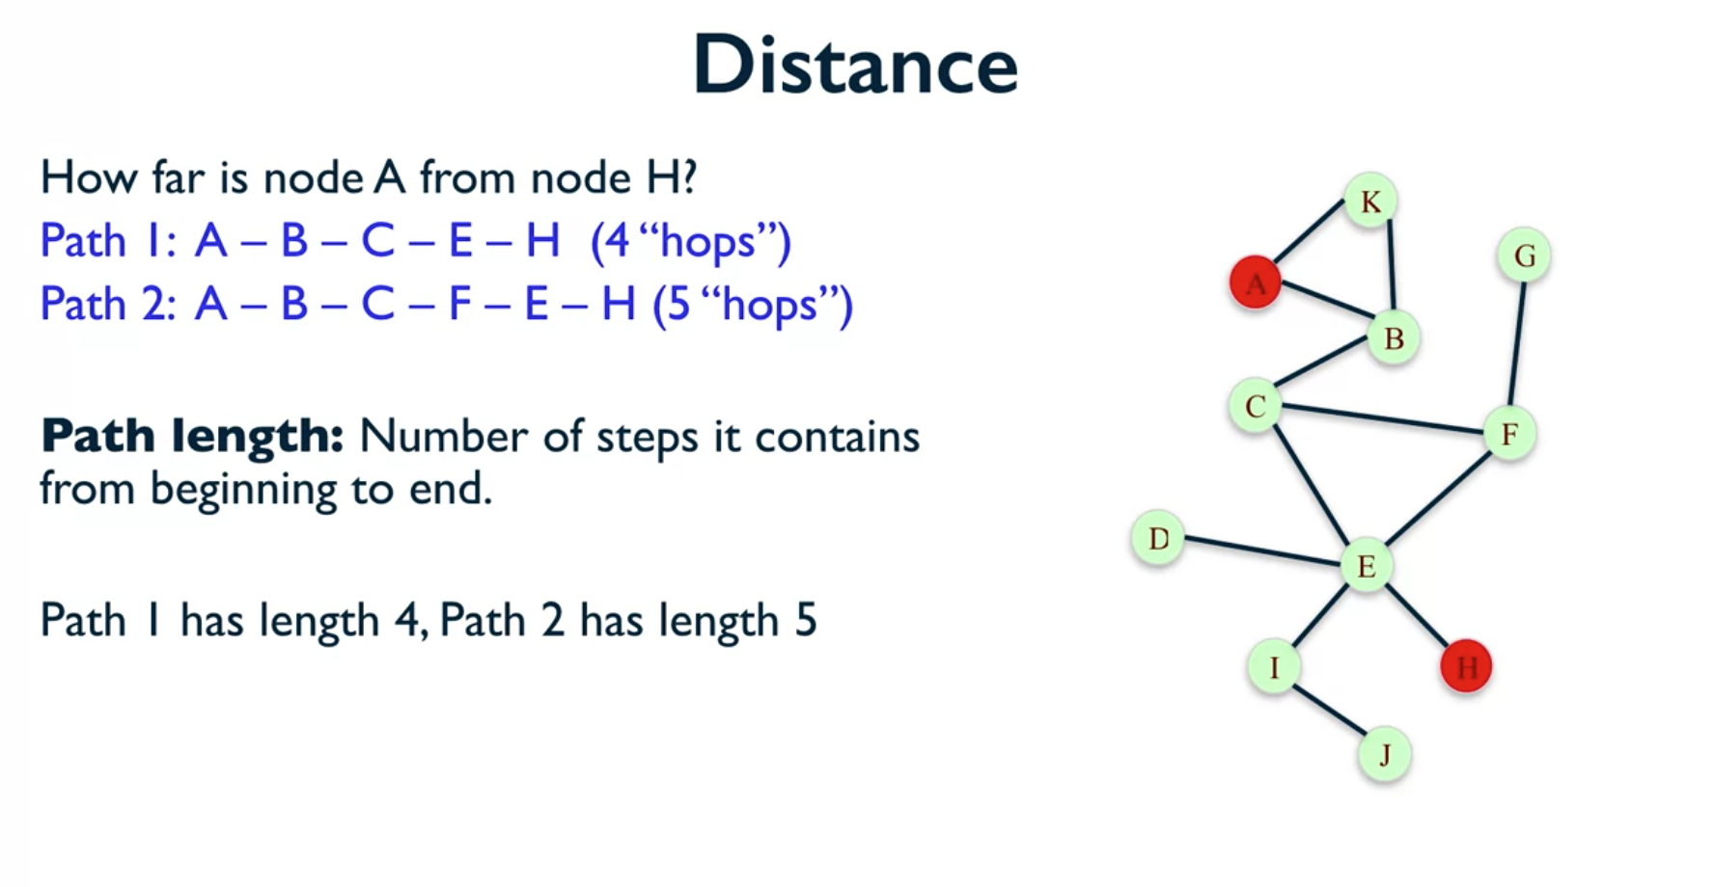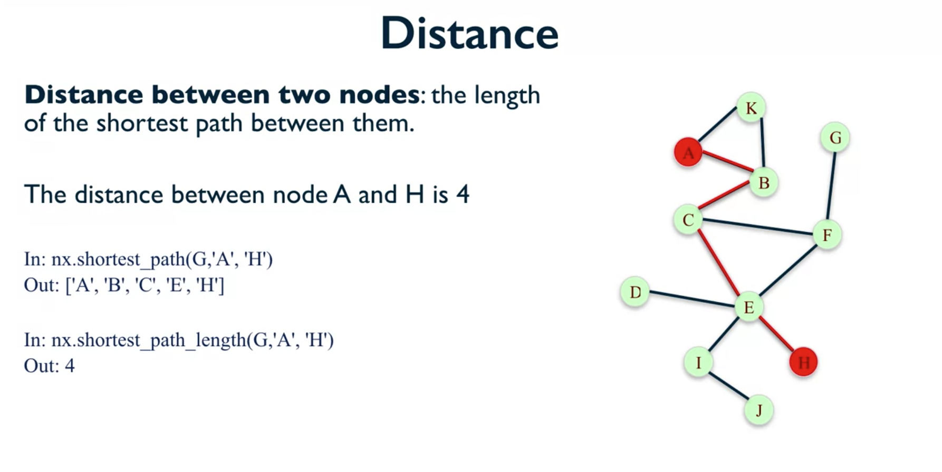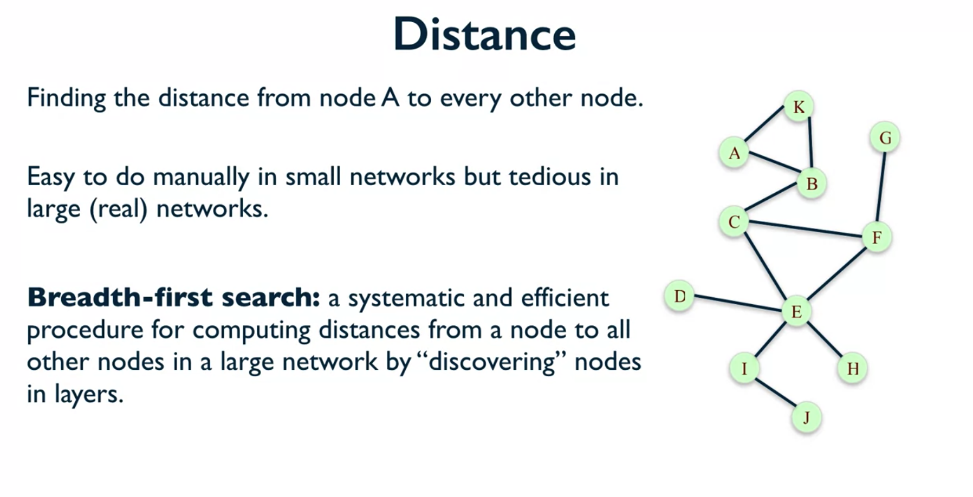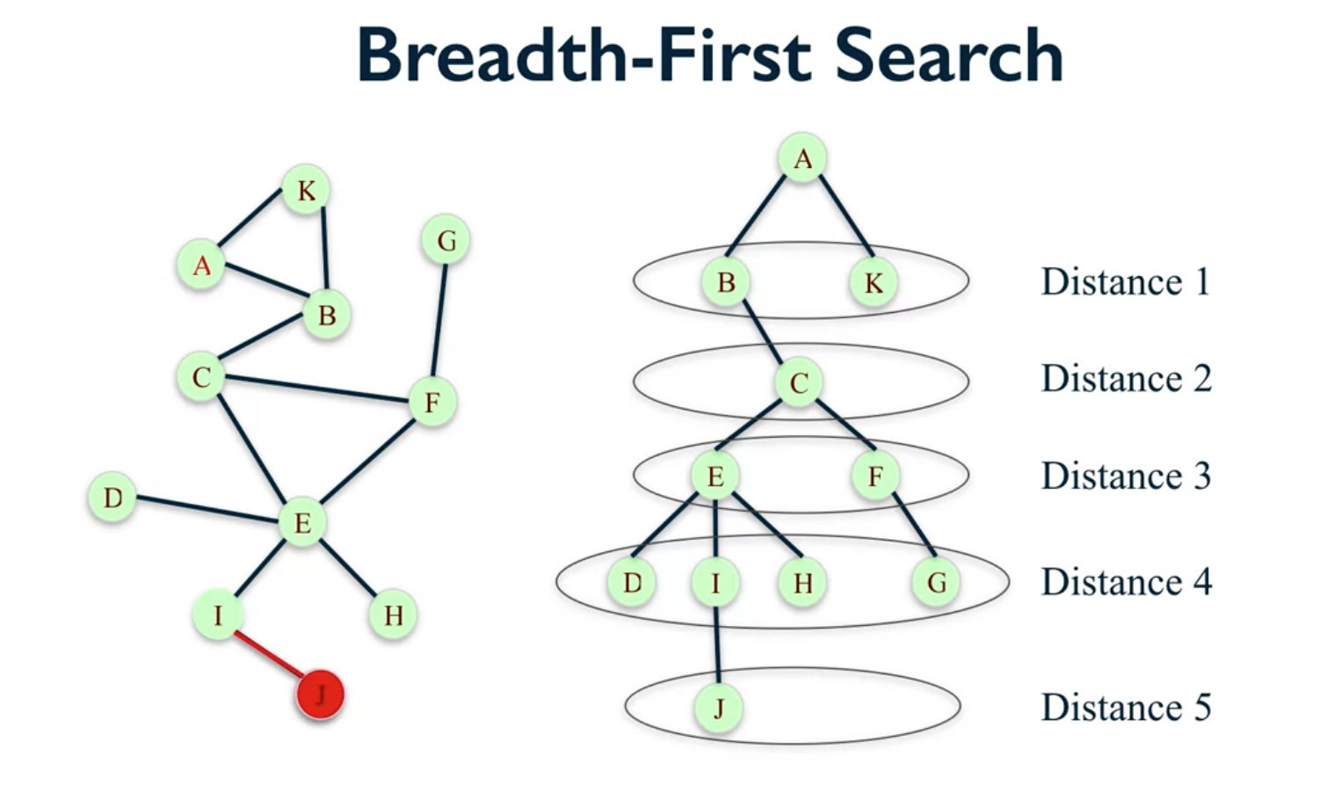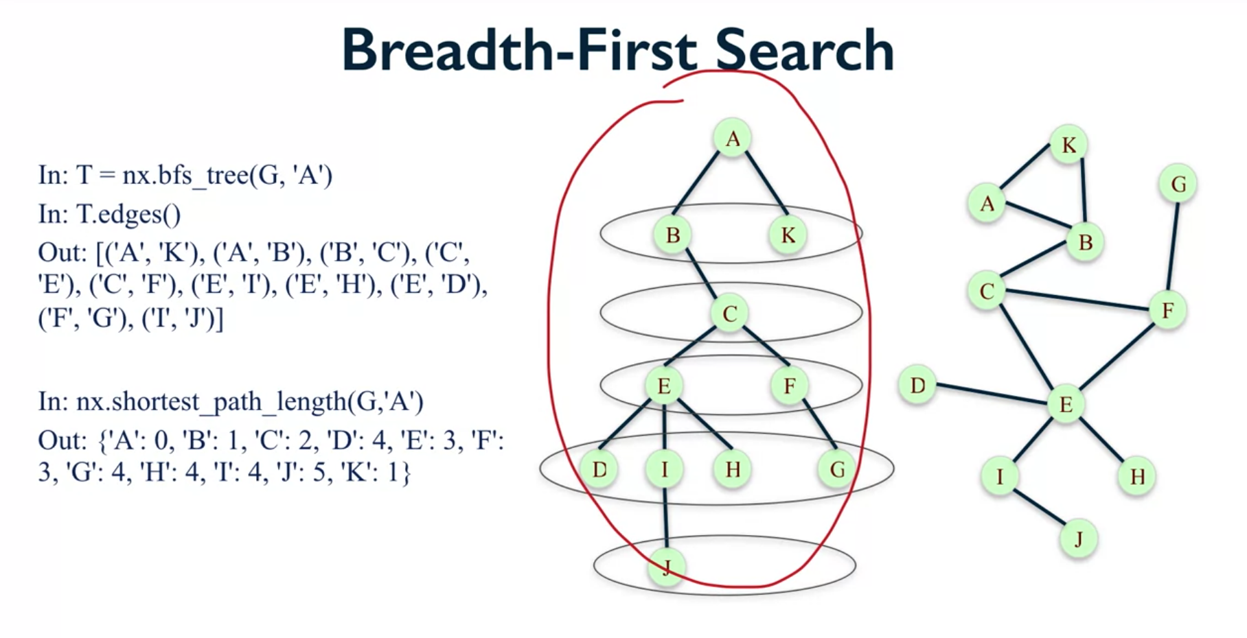

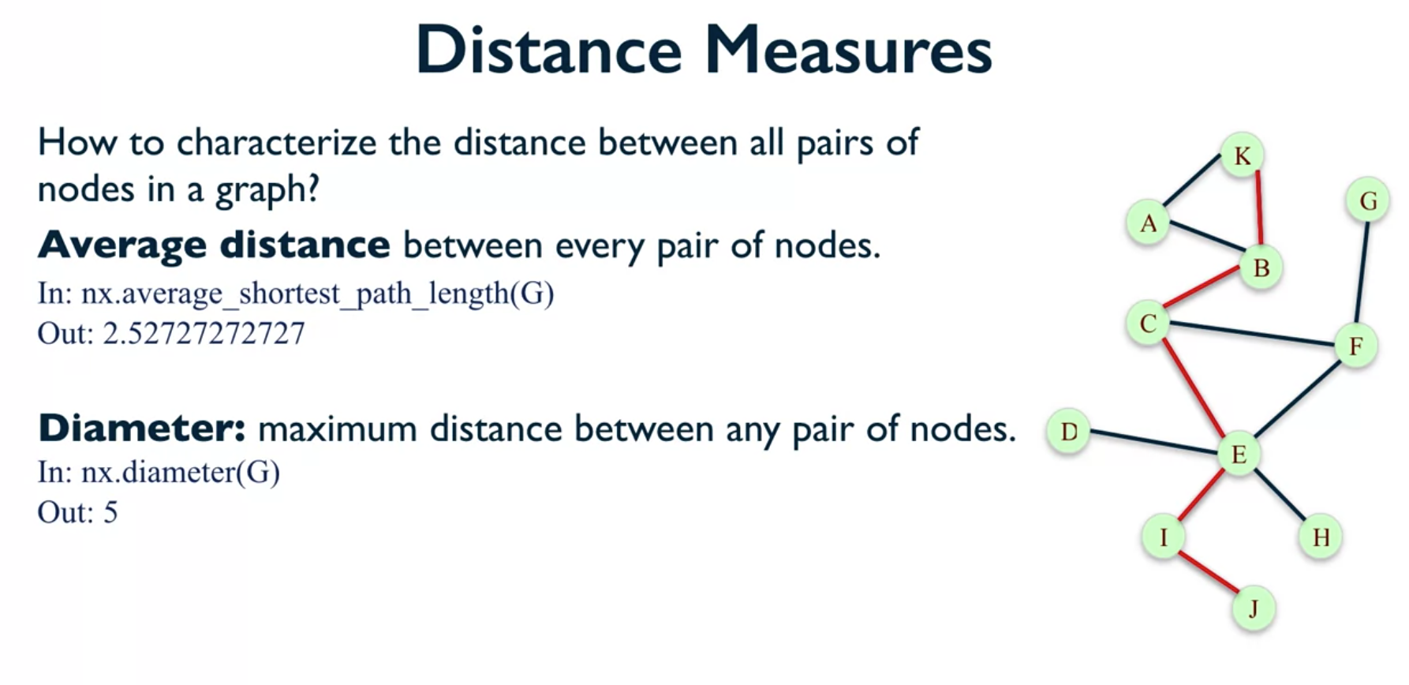

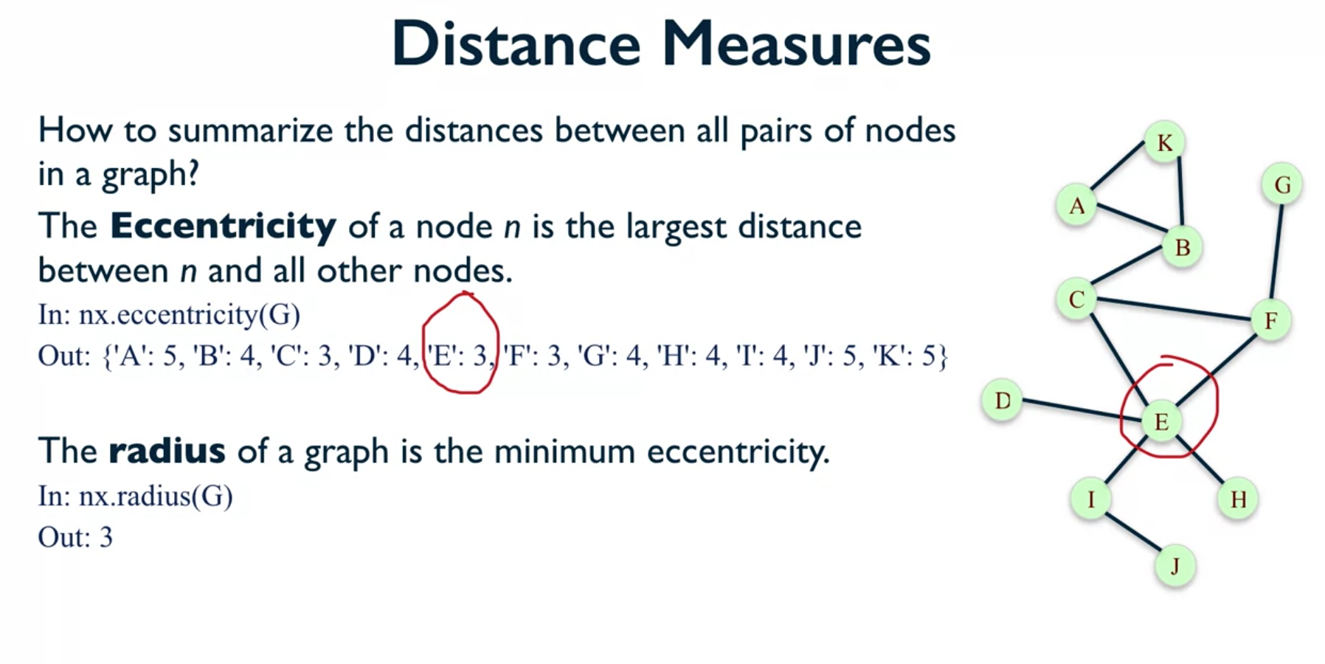

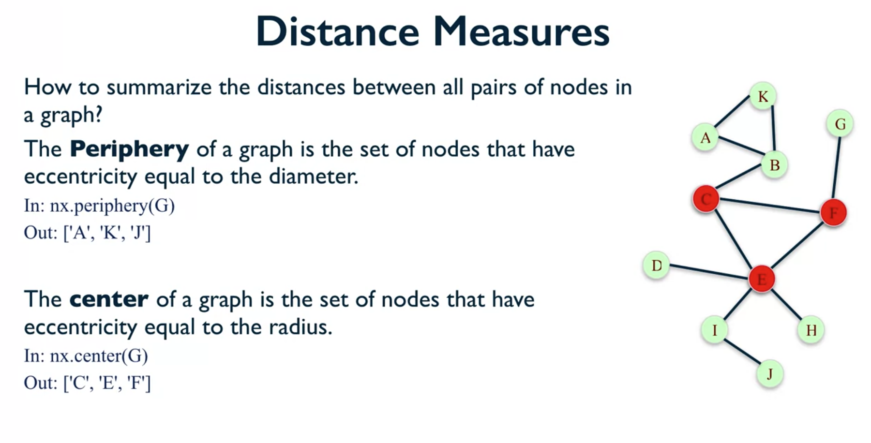

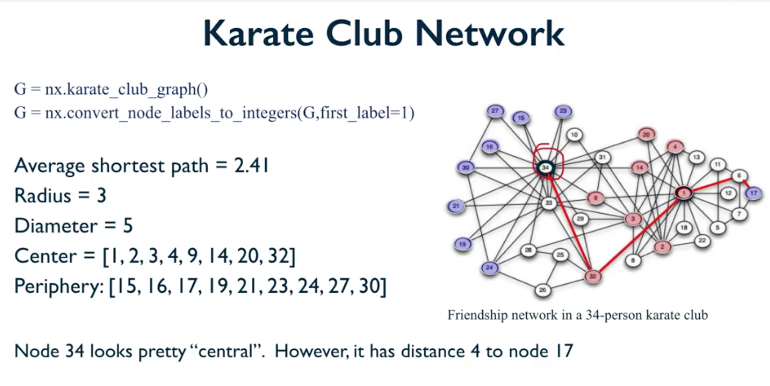

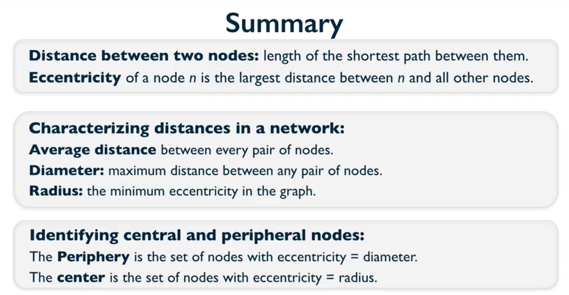

So, to summarize, we've looked at a set of measures. The first one is the distance between two nodes and that was defined to be the length of the shortest path between the two nodes and the eccentricity of a node, which is defined to be the largest distance between the node and all the other nodes in the network. Both of those definitions take place at the either node level or at the pair of nodes level. We've also looked at definitions that sort of take place at the whole graph level, they try to characterize the distances in the whole network and they were the average distance between any two pair of nodes. The diameter which is the largest distance between any two pair of nodes and then the radius which was the smallest eccentricity in the graph. And then, we use those definitions to identify the periphery and the center of the graph, which is the set of nodes, the periphery is the sets of nodes with eccentricity equal to the diameter and the center is a set of nodes with eccentricity equal to the radius. And that's all for this video and I hope to see you in the next one.

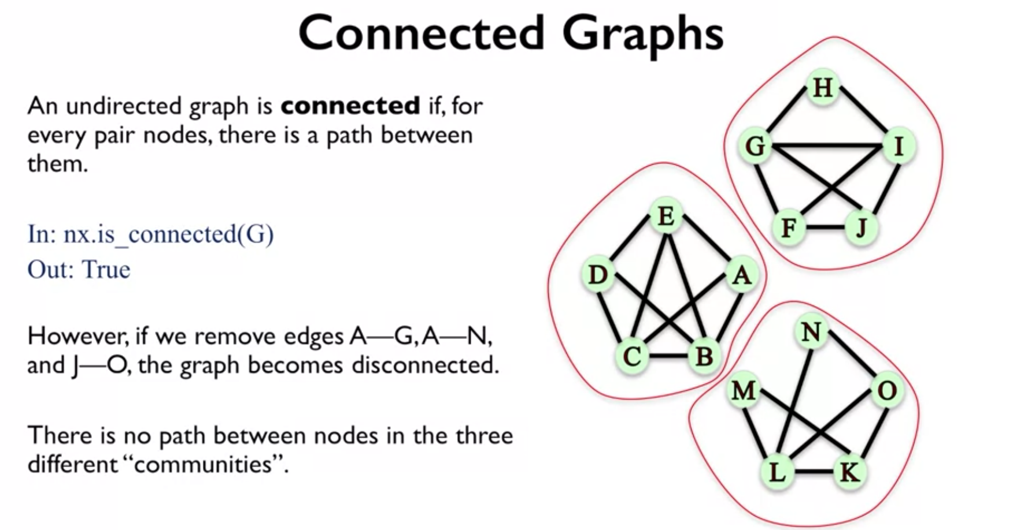

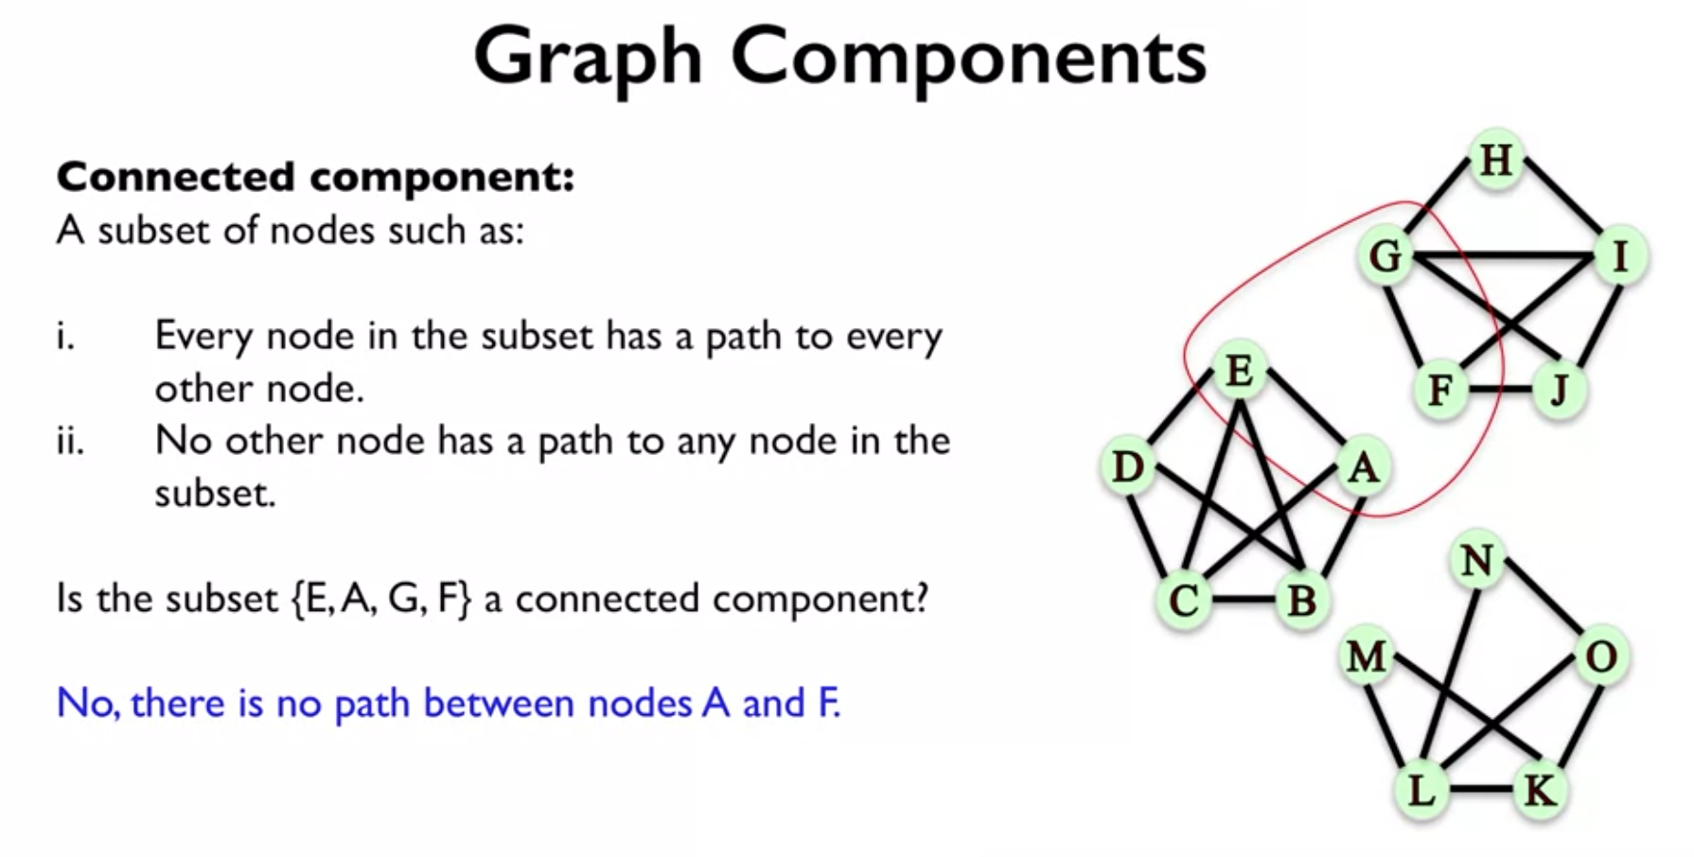

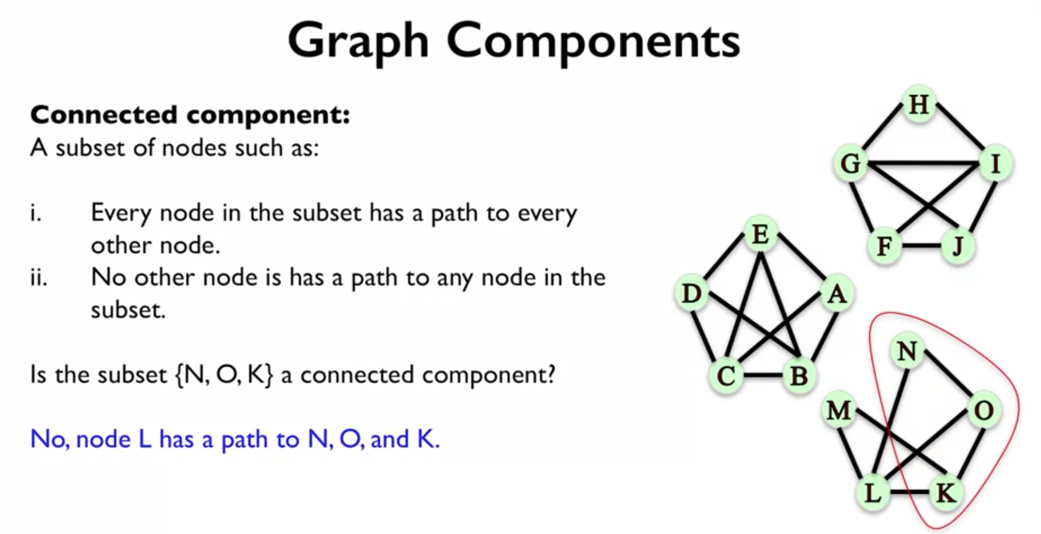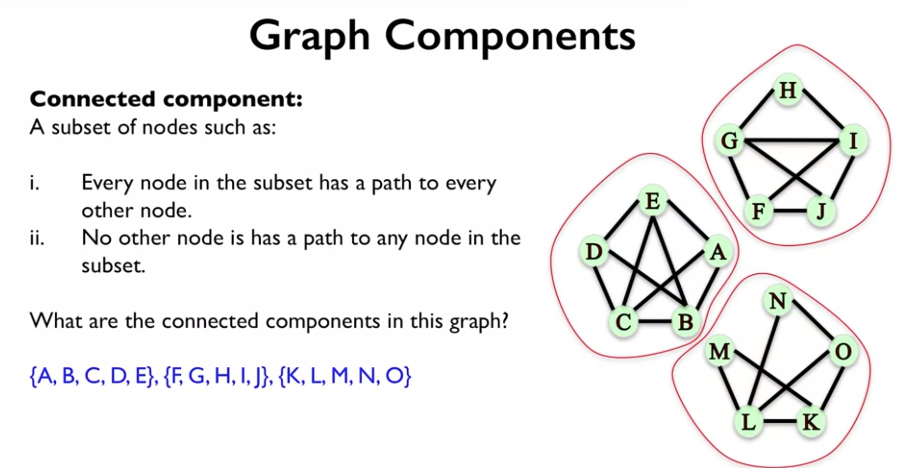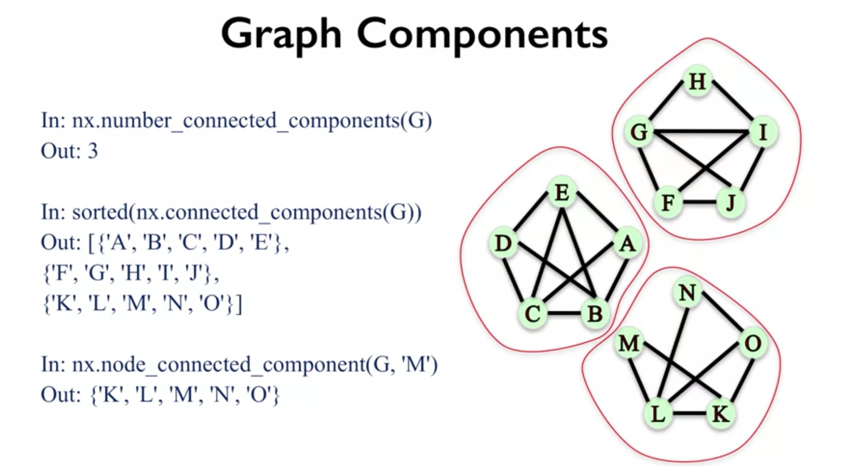

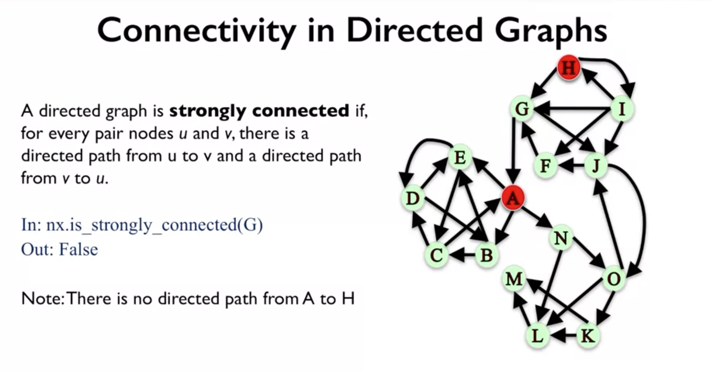

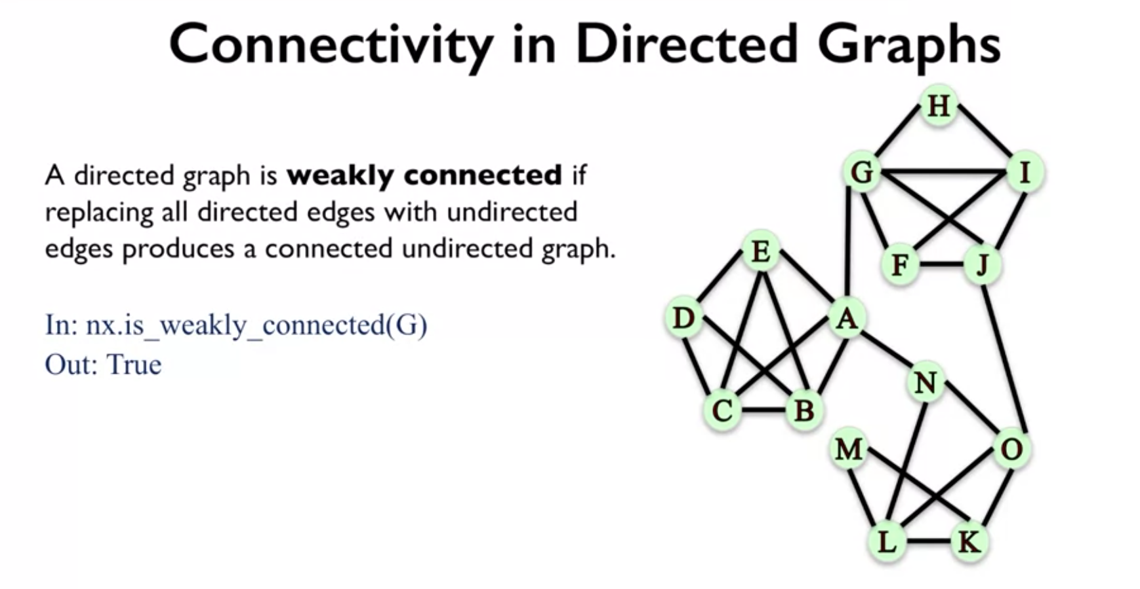

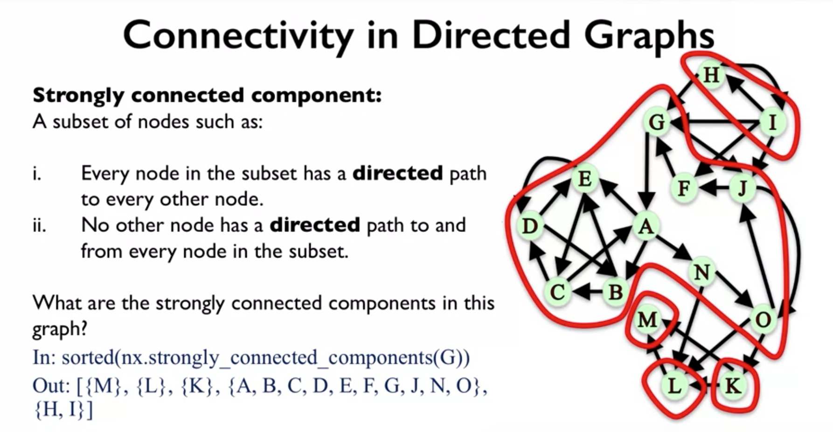

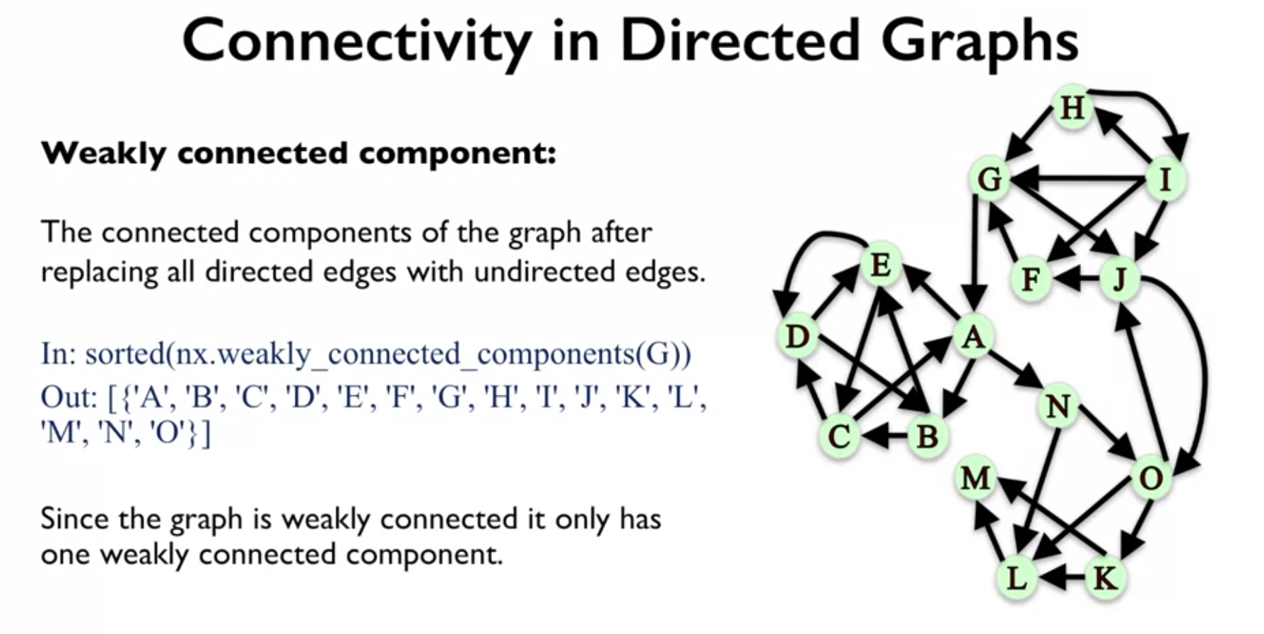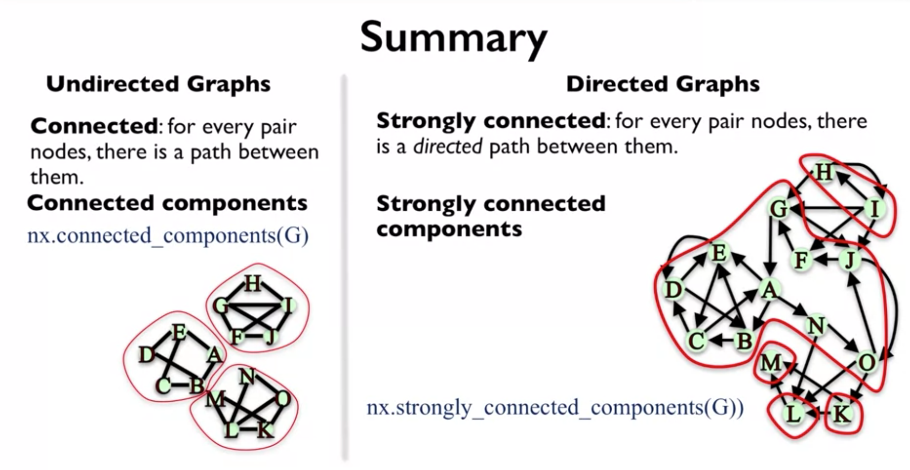

And so, to summarize, we talked about undirected graphs and directed graphs and we were talking about a couple of definitions of connectivity. So for underactive graphs, we said that an undirected graph is connected if for every pair of nodes, there is a path between them. And we talked about connected components and we said that we could use the function connected_components to find these connected components, so here's an example. Now, for the directed case, we had two types of definitions, the strong and the weak. For the strongly connected, we said that our graph is strongly connected if every pair of nodes, they have a directed path from one node to the other and from the other node to the one, and you could use the function strongly_connected_components to find what these components were. And both of these had the corresponding weak definitions, so weakly connected and weakly connected components. And the way that those work is by making the direct edges undirected, and then applying the same definitions that we had from undirected graphs to the new undirected graph that comes from the directed graph. Thank you for watching and we'll see you next time.

